Enterprise Networking Project / Simple Networking Project
Design a network in CISCO packet tracer to connect ACCOUNTS and DELIVERY departments through the following:
- Each department should contain at least 2 PCs
- Appropriate number of switches and routers should be used in the network
- Using the given network address 192.168.40.0, all interfaces should be configured with appropriate IP address, subnet mask and gateway
- All devices in the network should be connected using appropriate cables
- Test the connectivity between ACCOUNTS and DELIVERY department PCs in DELIVERY department should be able to ping the PCs in ACCOUNTS department.

Topology
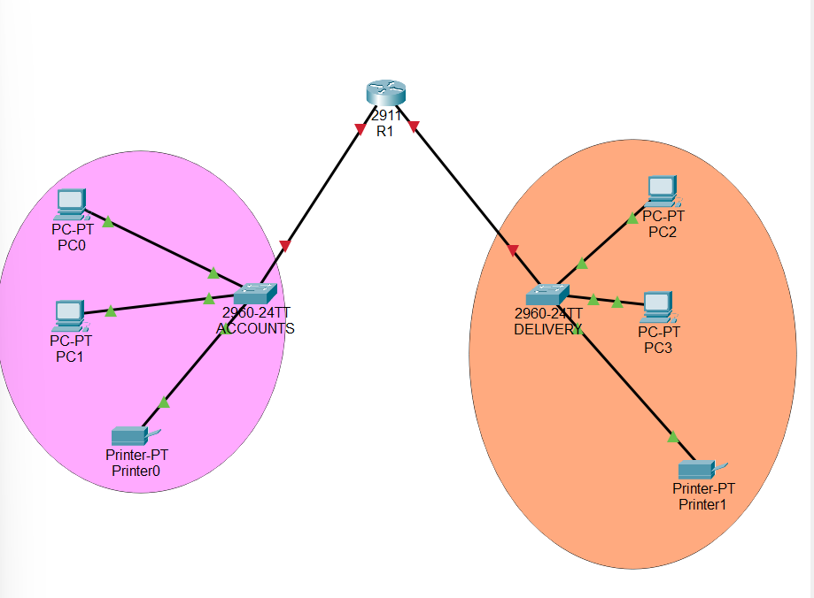
Subnetting Network
- Network address = 192.168.40.0
- Number of network = 2
2^n=# of subnets ===== 2^n=2

N=1
255.255.255.255
11111111.11111111.11111111.10000000 -----Binary
255.255.255.128subnet mask
1st Subnet
Subnet mask = 255.255.255.128
Network ID = 192.168.40.0
Range of Vlid Host = 192.168.40.1 – 192.168.40.126
Broadcast ID = 192.168.40.127

2st Subnet
Subnet mask = 255.255.255.128
Network ID = 192.168.40.128
Range of Vlid Host = 192.168.40.129 – 192.168.40.254
Broadcast ID = 192.168.40.255
IP address
ACCOUNTS
R1
R1(config)#int g0/0
R1(config-if)#ip add 192.168.40.1 255.255.255.128
R1(config-if)#no shut

PC0 – 192.168.40.2 255.255.255.128 192.168.40.1
PC1 – 192.168.40.3 255.255.255.128 192.168.40.1
Printer – 192.168.40.4 255.255.255.128 192.168.40.1

DELIVERY
R1
R1(config-if)#int g0/1
R1(config-if)#ip add 192.168.40.129 255.255.255.128
R1(config-if)#no shut

PC2 – 192.168.40.130 255.255.255.128 192.168.40.129
PC3 – 192.168.40.131 255.255.255.128 192.168.40.129
Printer – 192.168.40.132 255.255.255.128 192.168.40.129

